المحاضرة الرابعة – ثالثة تربية كيمياء – كيمياء فيزيائية
Phase rule – قاعدة الصنف
Three : Phase diagram of sulpher system
It is a one-component system comprising four phases, viz. (a) rhombic (b) monoclinic (c) liquid and (d) vapor sulpher,. This atypical example of a one component system exhibiting solid-solid transformation.
Sulpher exists in two well-known crystalline forms, namely rhombic and monoclinic sulpher. The two forms are in equilibrium at 95.5 ºC, which is called its transition temperature. Its defined as the " temperature at which one stable form of a solid is transformed into another stable solid form of it, without any change in temperature and pressure on the system being one atmosphere".
Then, the degree of freedom is
$$F= C−P+2= 1−4+2 = −1$$
Thus, we get $F= −1$, which is meaningless, Hence, for a system of single component, it is not possible to have four phases together in equilibrium. However, three or fewer number of phases can exist together.
The phase diagram of the sulpher shown in fig. 18. The diagram consists of six stable curves (BO, OA, AE, OC, AC, and CF) and four metastable curves (OD, OG, AD, and CD). The curves divide the diagram into four areas, i.e. to the left of BOCF, below BOAE, to right of FCAE and one enclosed by OCA.

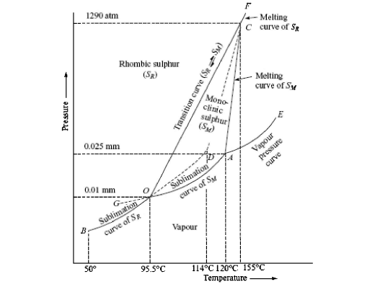
Fig. 18 phase diagram sulpher system
- Areas : the areas are bivariant, meaning that to locate at any point in the areas, both temperature and pressure are to be specified. Each area represents the conditions for the stable existence of a single phase. In the areas, thus, there are two degree of freedom, which also follows from the phase-rule equation, $F=C−P+2=1−1+2=2$.
In the area to the left of BOCF, only S_{R} (rhombic sulpher) exists while in the area below BOAE, only S_{V} (sulpher vapor) exists; to the right of FACE, S_{L} (liquid sulpher) is present and in the region enclosed by OCA, S_{M} (monoclinic sulpher) exists.
- Curves:
- OB-sublimation curve of Rhombic sulpher: the phases present in equilibrium along this curve are S_{R} and S_{V}. The cure starts from the point O, the transition temperature of S_{R} to S_{M} and ends at B (50 ºC) below which vapor pressure of S_{R} cannot be measured. If heating is done rapidly, then it is possible to heat rhombic sulpher above the transition point along OD, the metastable curve. On slight disturbance in merges into the curve OA, which is the vapor –pressure curve of monoclinic sulpher.
- OA-Sublimation curve of monoclinic sulpher : the two phases present in equilibrium along the curve are S_{M} and S_{V}. The curve starts from the point A, melting point of S_{M} (120 ºC) and ends at O, the transition temperature of S_{R} (95.5 ºC).
Except at the point O, where three phases S_{R}, S_{M} and S_{V} are present in equilibrium, at any other point all along the curve only two phases S_{R} and S_{M} are in equilibrium. For a fixed value of temperature and pressure is automatically fixed. The degree of freedom is one
If the temperature of monoclinic sulpher is lowered then it would change into rhombic sulpher at 95.5 ºC, but it is possible to prevent this conversion by careful cooling. Then we will move the curve OG which is a metastable vapor pressure curve of monoclinic sulpher.
- AE- vapor pressure curve of liquid sulpher : the two phases present in equilibrium along this curve are liquid sulpher S_{L} and vapor sulpher S_{V}. The curve starts A, the melting point of S_{M,} and ends at E, the critical point beyond which out of the two phases S_{L} and S_{V} only S_{V} can exist. For any point on the curve, for a fixed value of pressure, temperature has a fixed value. Therefore, the system also has one degree of freedom. The extended curve AD represents the metastable vaporization curve of liquid sulpher.
- OC- it is transition curve and represent the equilibrium between rhombic and monoclinic sulpher and is obtained from the effect of pressure on the transition temperature of rhombic sulpher.
The slope of the curve OC is away from the vertical pressure axis, indicating that the transition point is raised by the rise of pressure. The curve ends at the point C, after which the monoclinic sulpher phase disappears.
- AC- it is the transition curve and represents the equilibrium between monoclinic and liquid sulpher and results from the effect of pressure on the melting point S_{M}. The curve is inclined away from the pressure axis showing that the melting point rises with rise of pressure. The curve ends at the point C, after which monoclinic sulpher phase disappears.
- CD- the curve represents the equilibrium between rhombic and liquid sulpher and the metastable melting point curve of rhombic sulpher. The curve OC and AC meet at a C, at 155 ºC and 1290 atmospheres. It follows, therefore, that if liquid sulpher curve were cooled at a pressure higher than 1290 atmospheres the rhombic sulpher would crystallize at once, no monoclinic sulpher being formed. The curve passes through the point C and beyond this point, it becomes a stable melting point curve CF of rhombic sulpher.
- Triple points : there are three stable triple points, via O, A, and C, in the phase diagram. At the point O, three phases in equilibrium are S_{R},S_{M} and S_{V}. If one of the variables is changed, one of the three phases disappear. Similarly, A is also a triple point between S_{M}, S_{V} and S_{L}. Thus point is again invariant. Further, line OC and AC intersect at C to yield a three-phase equilibrium between S_{R},S_{M} and S_{L.} Since on changing one of the variables, either pressure or temperature, one of the phases disappears, therefore, the system at the triple point has no degree of freedom
$$F=C−P+2=1−3+2=0$$
D is the metastable triple point, the phases in equilibrium being S_{R},S_{M} and S_{V.}

